**DISK MANGAMENT-2**

Create LVM

Hard Disks --> Partitions

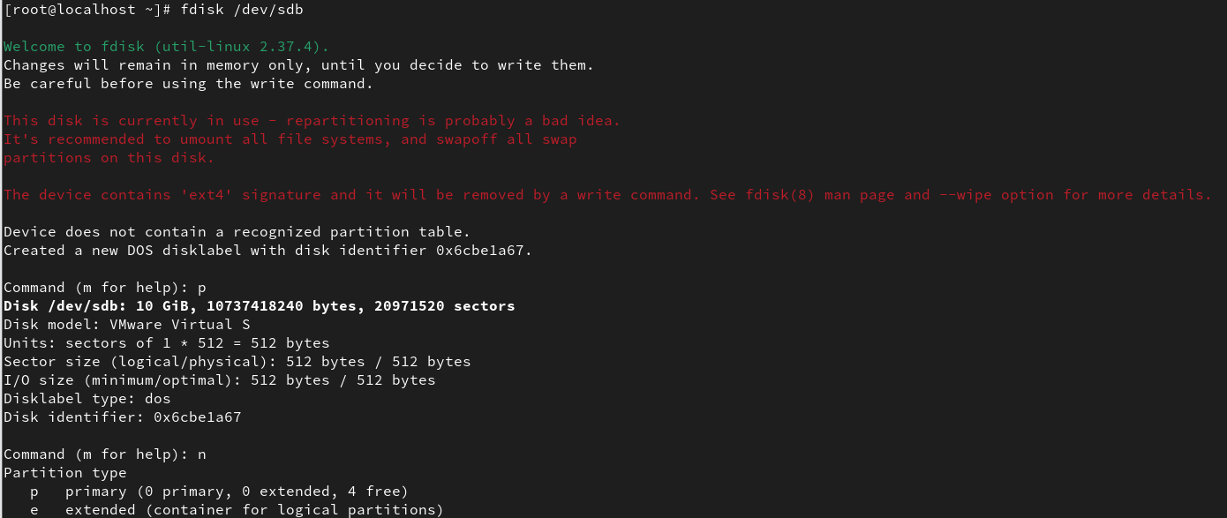

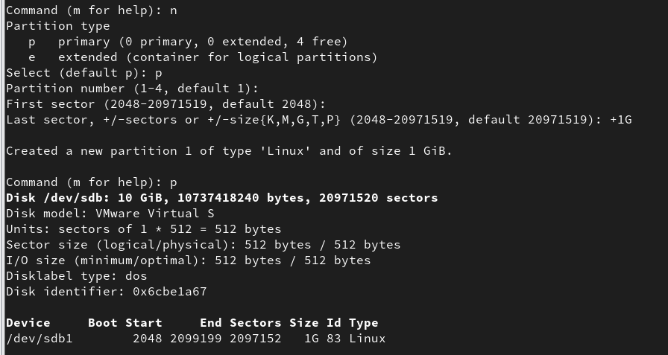

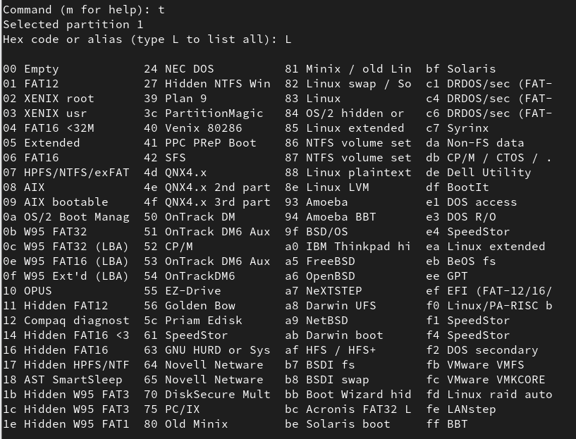

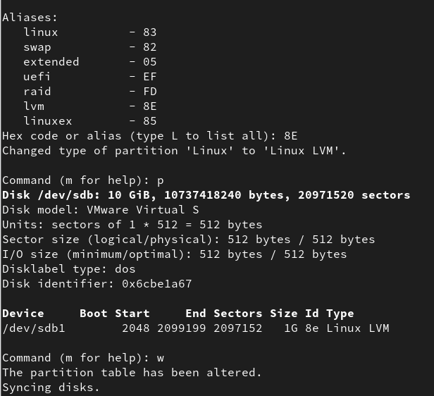

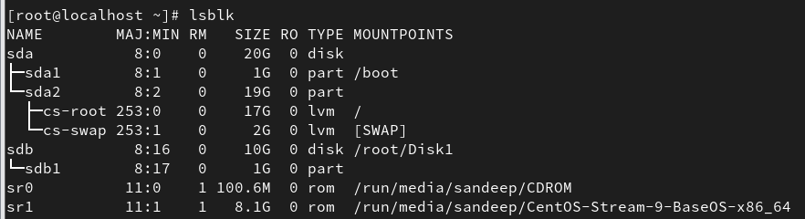

#lvmdiskscan— List devices that may be used as physical volumes

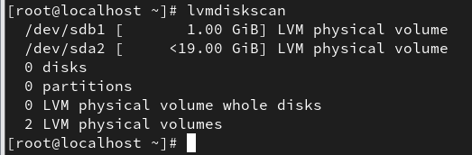

create physical volume

#pvcreate /dev/sdb1



Create volume group

#vgcreate vg_mydata /dev/sdb1



# Create logical volume

#lvcreate -L 500M -n lv_mydata vg_mydata



# Create filesystem

# mkfs.xfs /dev/vg_mydata/lv_mydata

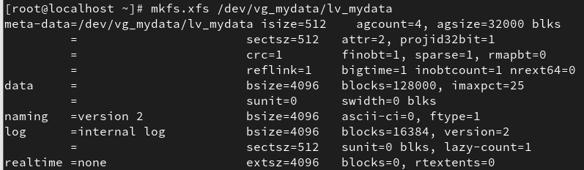

Mount the filesystem

1. Create Dir

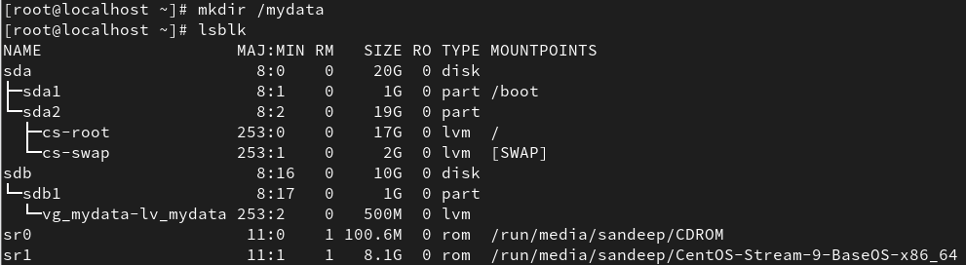

1. Now mount

# mount /dev/vg_mydata/lv_mydata /mydata

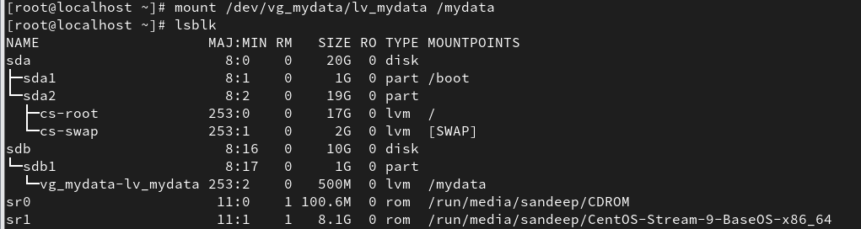

command to check mounted filesystem

#df -h ,df -hT , lsblk

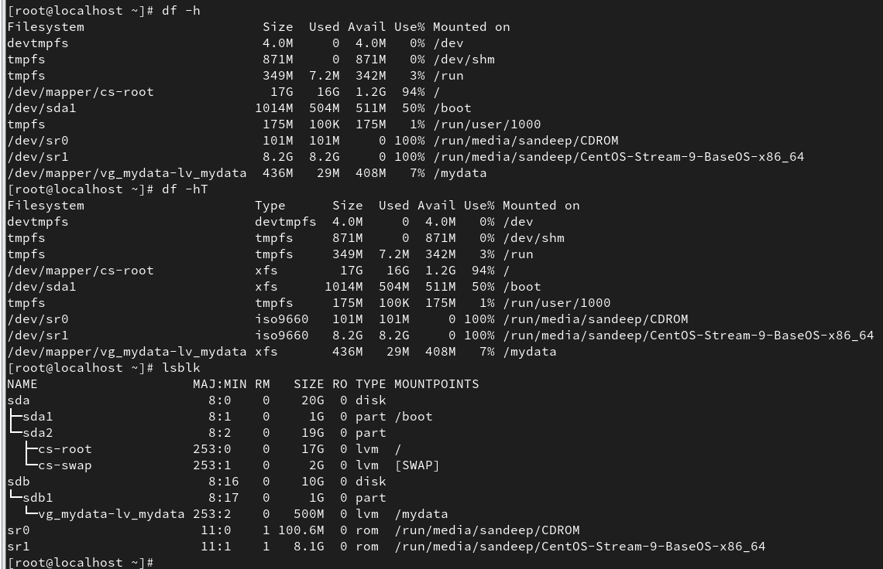

# pvdisplay

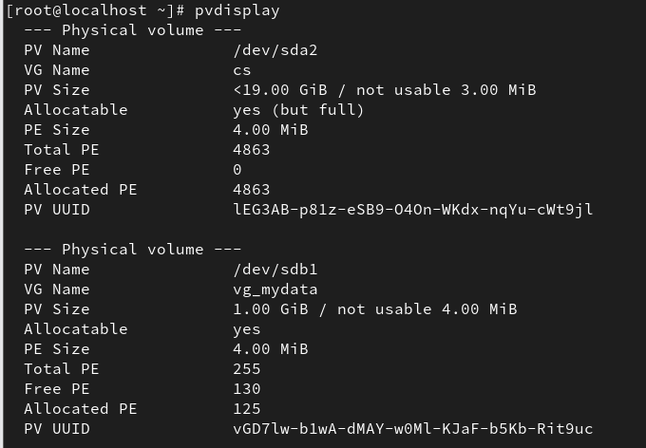

# lvdisplay

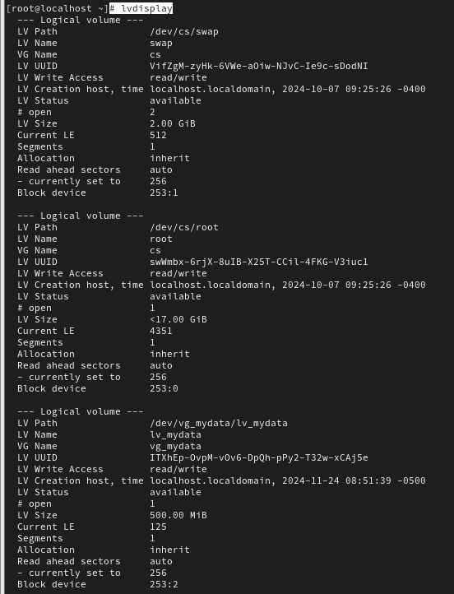

# vgdisplay

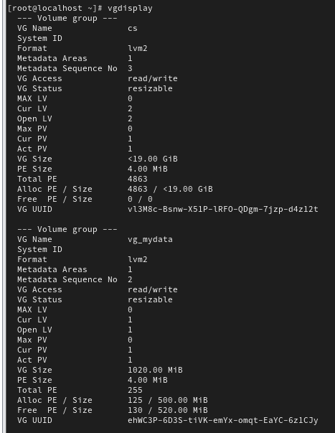

#pvscan



#lvscan

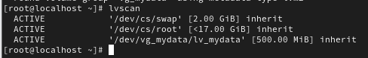

#vgscan

